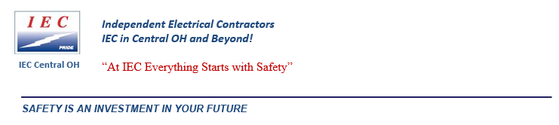

TOOLBOX TALK # 987 Date : April 27, 2020

**Not a Big Deal Until It Is**

Most of us have heard of the saying “it is not a big deal until it is”. Whether it is related to production or safety, there are always issues that are recognized, but nothing is done to correct them in a timely matter. These issues are left unchanged until something occurs and then it becomes a huge deal to upper management or someone else. This kind of situation occurs every day at many companies. When these situations occur when dealing with workplace safety, leaving hazards unaddressed can lead to injuries or worse. When an injury occurs, that unaddressed hazard is sure to become a big deal.

**Unaddressed Hazards in the Workplace**

How many hazards are knowingly walked past every day at work? Why is this a common occurrence at many jobsites? Are employees lazy? Are managers careless? Does no one care? The list of reasons for why hazards are walked past and left unaddressed can be a long one. A few common related responses when asking why a hazard is left unaddressed are:

* “It’s not a big deal”
* “It will be okay”
* “It has always been like that, no one is worried about it”

The problem with these responses is that it shows that [there is complacency](https://www.safetytalkideas.com/safetytalks/battling-complacency/) towards the situation as well as there are multiple people not taking action to correct the hazard. These type of responses often show that bigger problems are present, not just the carelessness of one or two individuals.

**When a Hazard Becomes a Big Deal**

Mentioned above, we have all witnessed situations that are much like ticking time bombs in the workplace. For the most part, we all know what needs to be done and we know what the expectation is for the work that we do including working safely. Often times the upper management of a company has high expectations for their worksites to work safely however, hazards are left unaddressed at an individual site level or in part of a facility. When an injury occurs due to a hazard that has been recognized but not corrected this is when it becomes a big deal for everyone involved.

Top of Form

**PLEASE READ AND UNDERSTAND THIS IMPORTANT DOCUMENT AND SIGN ON THE REVERSE SIDE THAT YOU HAVE DONE SO.**

**YOUR SIGNATURE ON THE REVERSE SIDE INDICATES THAT YOU HAVE READ AND UNDERSTAND THE CONTENTS OF THIS DOCUMENT!**

**________________________________________________________________________________________________________________________**Ph

Phone 614-473-1050 Fax 614-473-1359 email: BTipton@IECCentralOH.org website: [www.IECCentralOH.org](http://www.IECCentraloh.org)



SIGN-IN SHEET – April 27, 2020

TOOLBOX TALKS # 987 –Not a Big Deal Until It Is

My signature below indicates that I read and understand Toolbox Talk: “Not a Big Deal Until It Is”

**=====================================================================================================**

**PRINT YOUR NAME YOUR SIGNATURE DATE**

1. **___________________________________ ___________________________________________ __________________**
2. **___________________________________ ____________________________________________ _________________**
3. **____________________________________ ____________________________________________ ________________**
4. **____________________________________ ____________________________________________ ________________**
5. **____________________________________ ____________________________________________ ________________**
6. **_____________________________________ _________________________________________ _________________**
7. **_____________________________________ _________________________________________ _________________**
8. **_____________________________________ _________________________________________ __________________**
9. **_____________________________________ _________________________________________ __________________**
10. **_____________________________________ __________________________________________ _________________**
11. **_____________________________________ __________________________________________ _________________**
12. **_____________________________________ __________________________________________ _________________**
13. **_____________________________________ __________________________________________ _________________**
14. **_________________________________ ___________________________________________ ________________**
15. **____________________________________ ___________________________________________ _________________**